NATIONAL UNIVERSITY OF MODERN LANGUAGE ISLAMABAD
Lab final


Submitted to:
Mr. Yasir Ateeq
Submitted by:
Zulqarnain Hassan
Roll No: …………………… SP21379
Subject: …………………… DBMS
Department: ……………… BSSE-4-Afternoon
Date: ……………………… 24-05-2024

TASK 1
I

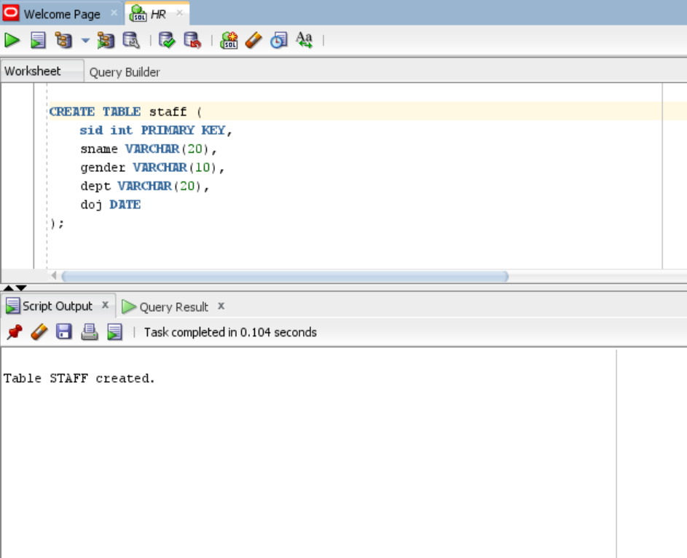

TASK 1
II

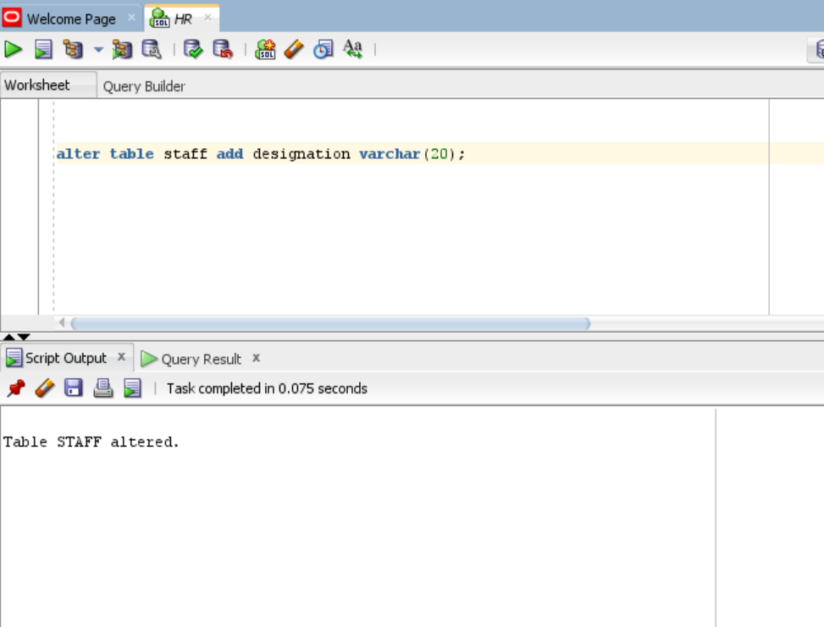

TASK 1
III

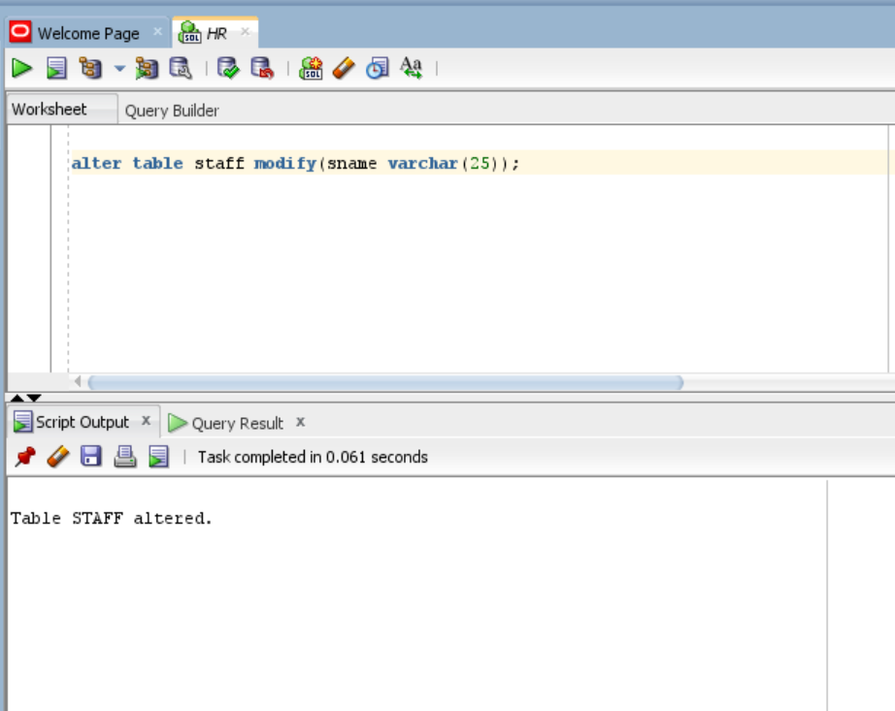

TASK 1
IV

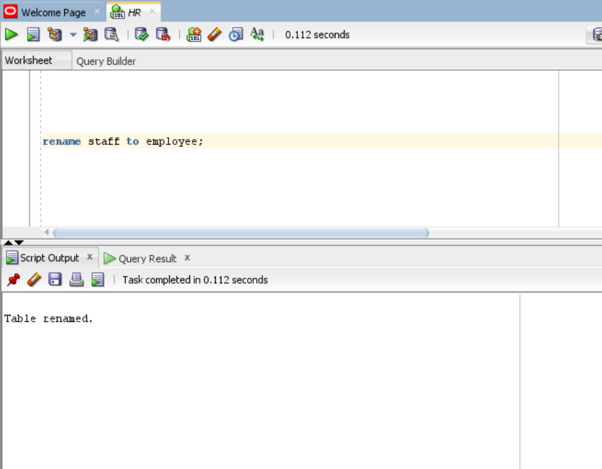

TASK 1
V

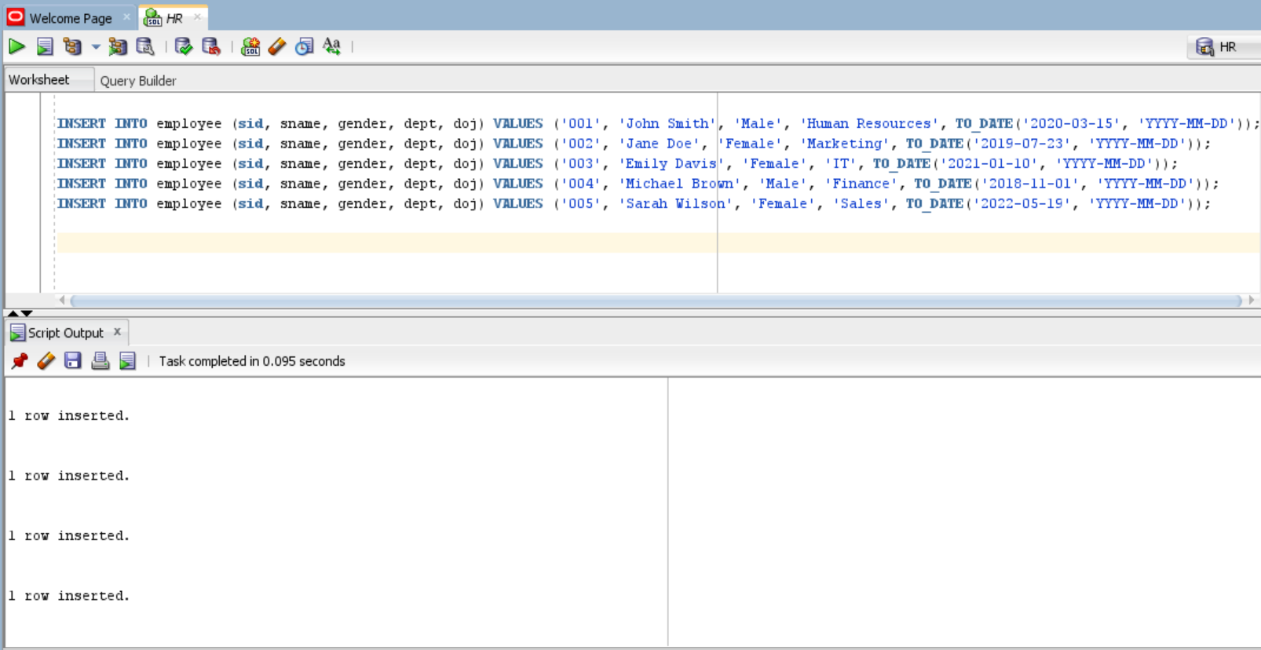

TASK 2
I
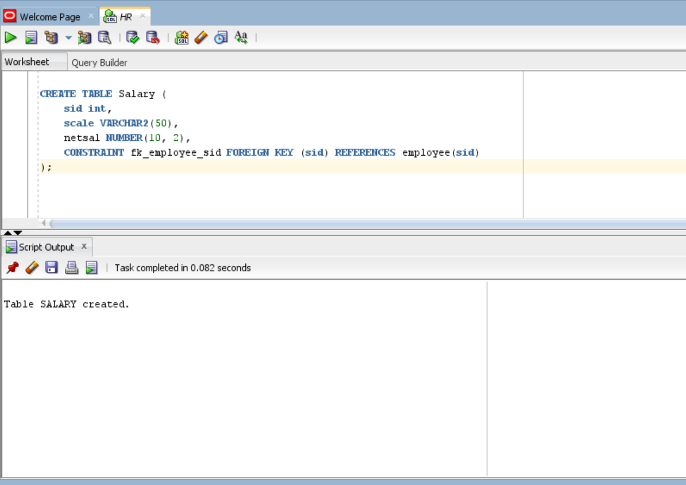

TASK 2
II
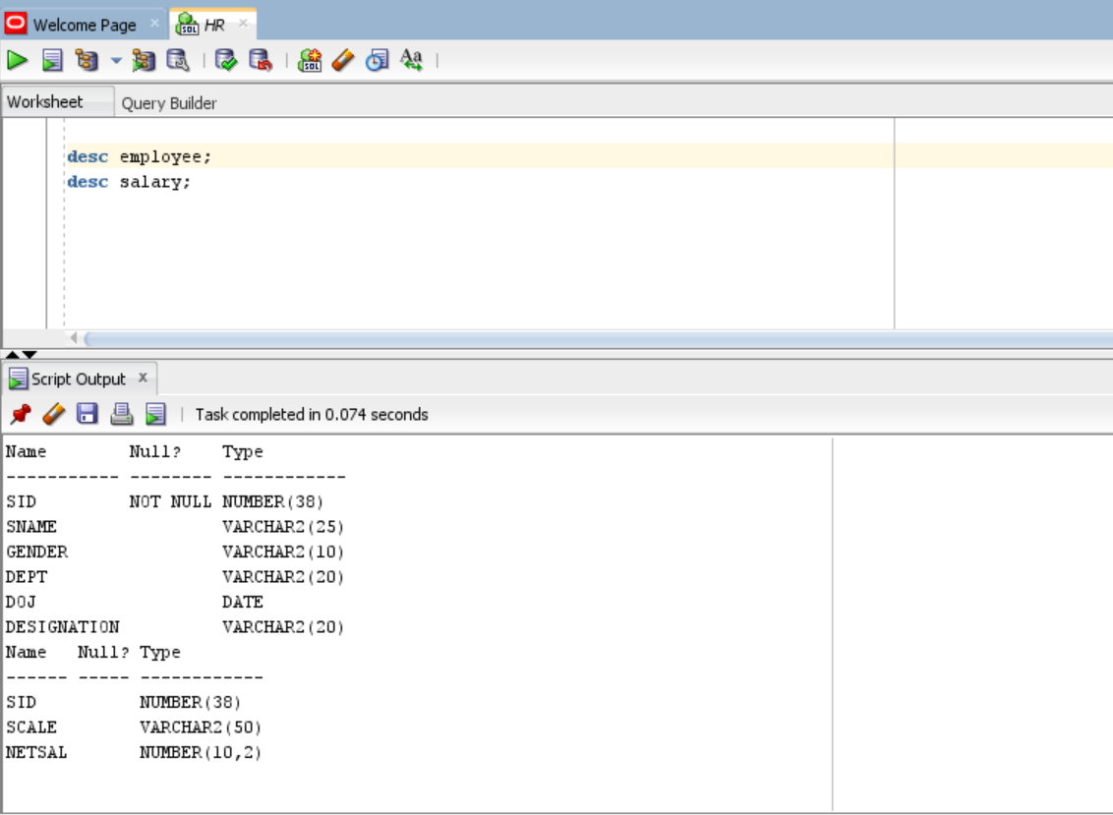

TASK 2
III
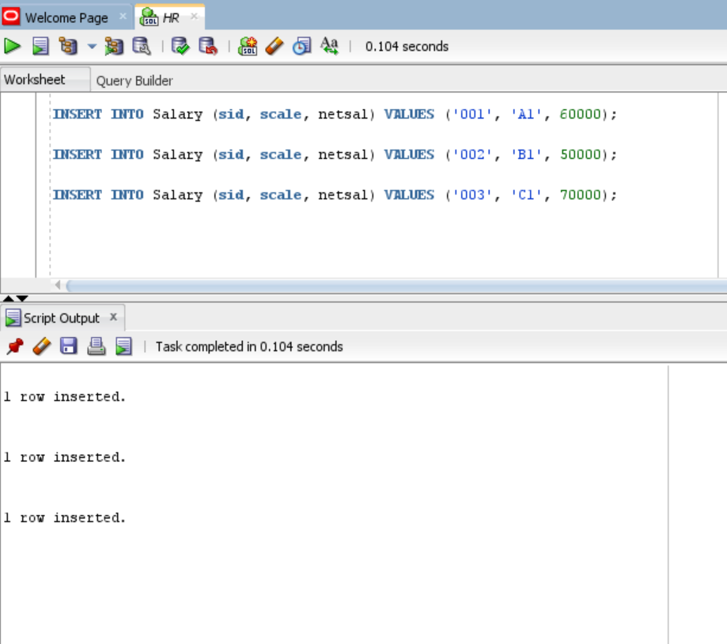

TASK 3
I
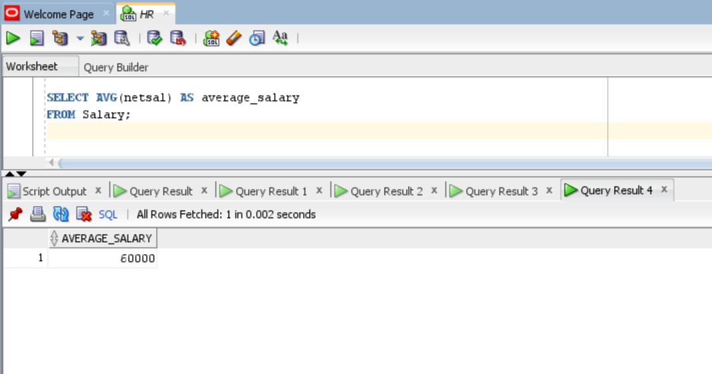

TASK 3
I
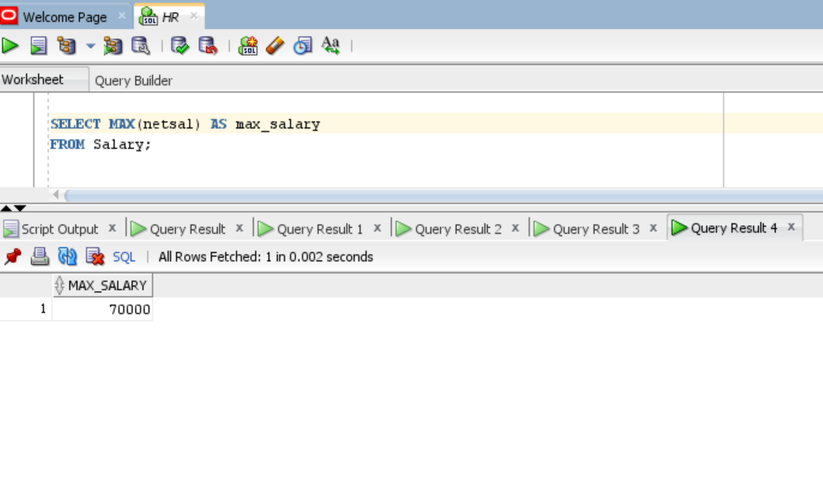
TASK 3
II

TASK 3
III
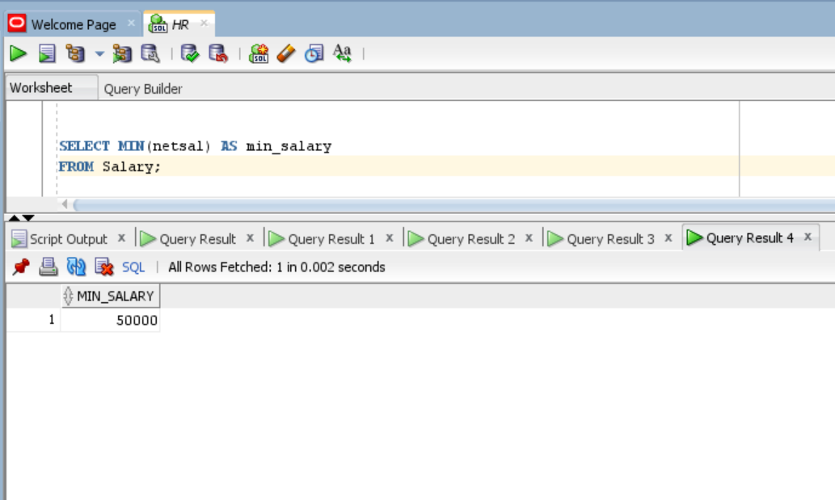
TASK 3
IV
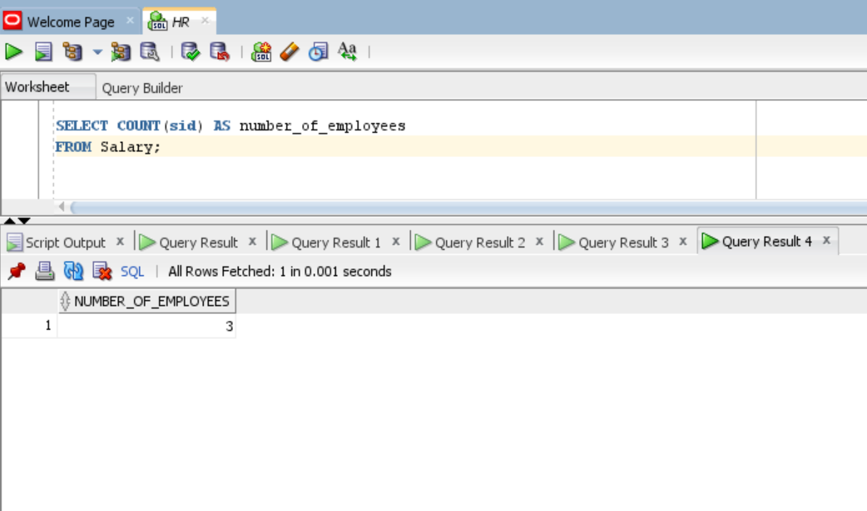
TASK 3
V
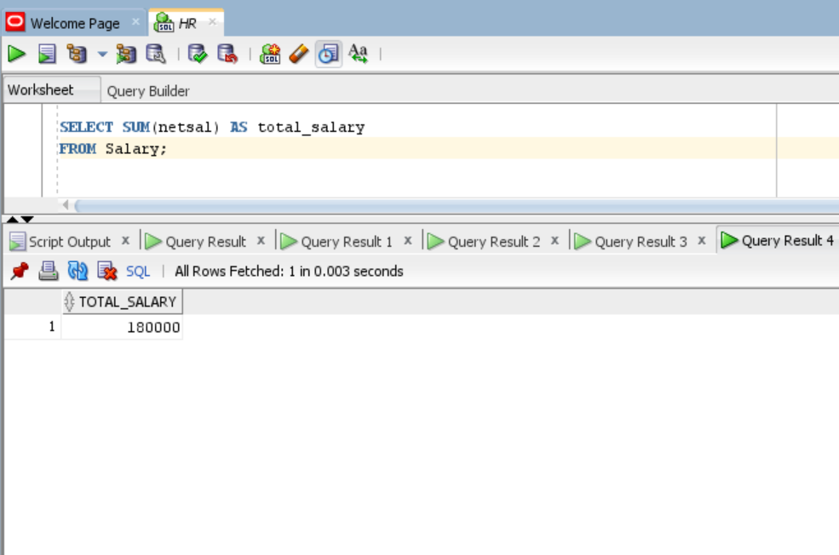

TASK 4
I
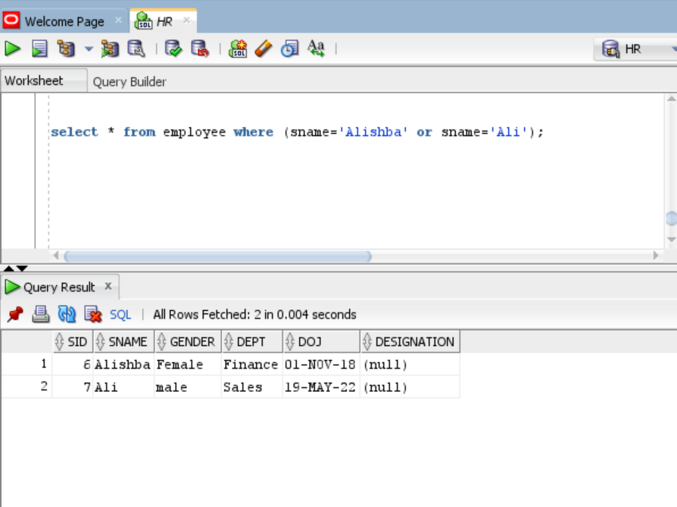

TASK 4
II
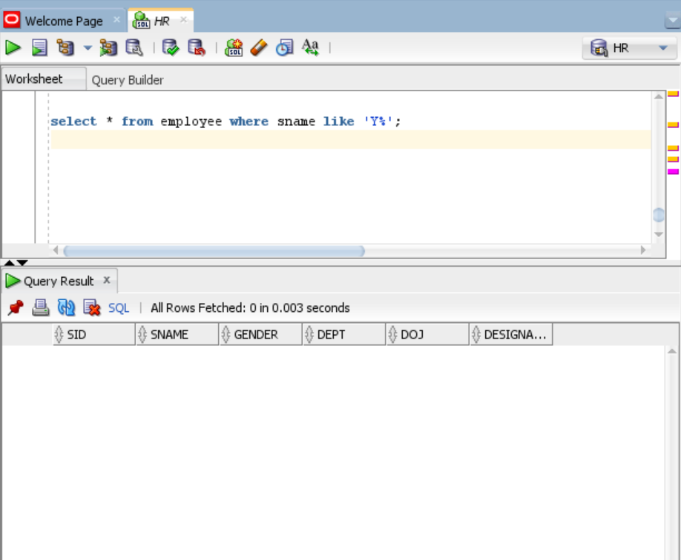

TASK 4
III
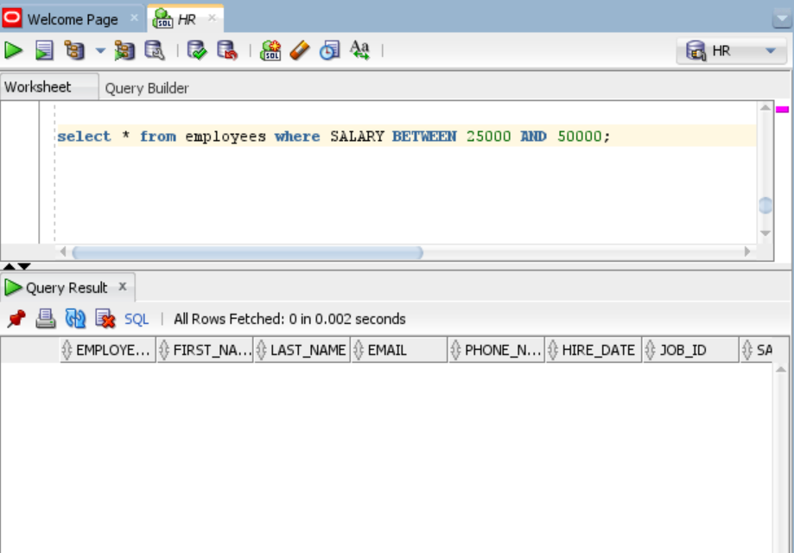

TASK 4
IV
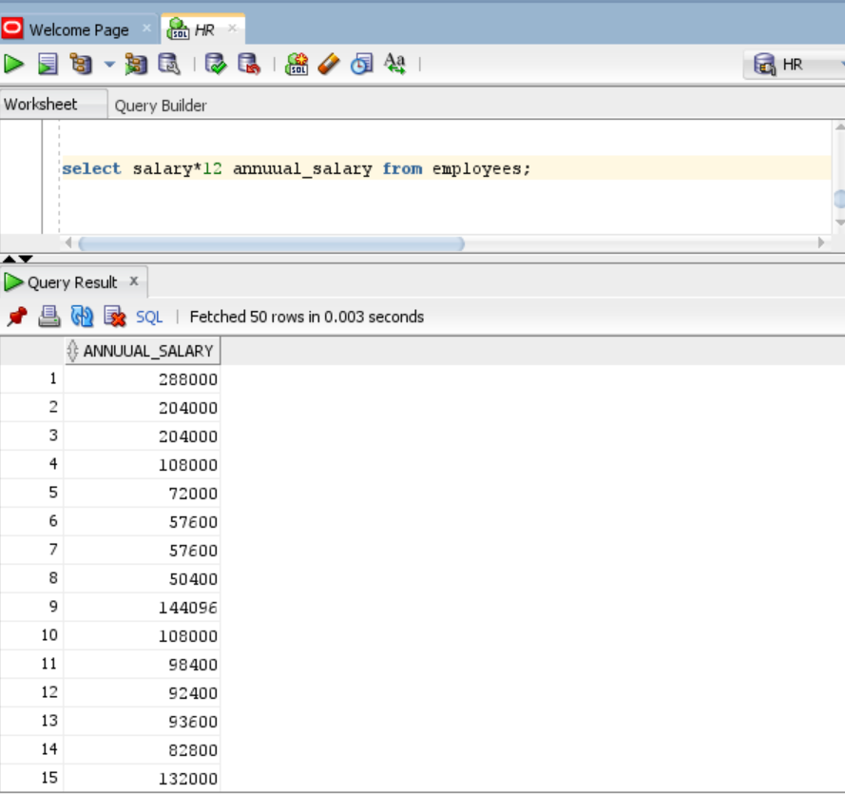

TASK 1
CREATE TABLE staff (
sid int PRIMARY KEY,
sname VARCHAR(20),
gender VARCHAR(10),
dept VARCHAR(20),
doj DATE
);

alter table staff add designation varchar(20);
alter table staff modify(sname varchar(25));
rename staff to employee;
INSERT INTO employee (sid, sname, gender, dept, doj) VALUES ('001', 'John Smith', 'Male', 'Human Resources', TO_DATE('2020-03-15', 'YYYY-MM-DD'));
INSERT INTO employee (sid, sname, gender, dept, doj) VALUES ('002', 'Jane Doe', 'Female', 'Marketing', TO_DATE('2019-07-23', 'YYYY-MM-DD'));
INSERT INTO employee (sid, sname, gender, dept, doj) VALUES ('003', 'Emily Davis', 'Female', 'IT', TO_DATE('2021-01-10', 'YYYY-MM-DD'));
INSERT INTO employee (sid, sname, gender, dept, doj) VALUES ('004', 'Michael Brown', 'Male', 'Finance', TO_DATE('2018-11-01', 'YYYY-MM-DD'));
INSERT INTO employee (sid, sname, gender, dept, doj) VALUES ('005', 'Sarah Wilson', 'Female', 'Sales', TO_DATE('2022-05-19', 'YYYY-MM-DD'));
INSERT INTO employee (sid, sname, gender, dept, doj) VALUES ('006', 'Alishba', 'Female', 'Finance', TO_DATE('2018-11-01', 'YYYY-MM-DD'));
INSERT INTO employee (sid, sname, gender, dept, doj) VALUES ('007', 'Ali', 'male', 'Sales', TO_DATE('2022-05-19', 'YYYY-MM-DD'));

task 2

CREATE TABLE Salary (
sid int,
scale VARCHAR2(50),
netsal NUMBER(10, 2),
CONSTRAINT fk_employee_sid FOREIGN KEY (sid) REFERENCES employee(sid)
);

desc employee;
desc salary;

INSERT INTO Salary (sid, scale, netsal) VALUES ('001', 'A1', 60000);

INSERT INTO Salary (sid, scale, netsal) VALUES ('002', 'B1', 50000);

INSERT INTO Salary (sid, scale, netsal) VALUES ('003', 'C1', 70000);

TASK3

SELECT SUM(netsal) AS total_salary FROM Salary;

SELECT AVG(netsal) AS average_salary FROM Salary;

SELECT MAX(netsal) AS max_salary FROM Salary;

SELECT MIN(netsal) AS min_salary FROM Salary;

SELECT COUNT(sid) AS number_of_employees FROM Salary;

TASK 4

select * from employee where (sname='Alishba' or sname='Ali');

select * from employee where sname like 'Y%';

select * from employees where SALARY BETWEEN 25000 AND 50000;

select salary*12 annuual_salary from employees;

